Introduction to Amazon Relational Database Service (RDS) - SQL Server

**SPL-145 Version 2.0.26**

© 2024 Amazon Web Services, Inc. or its affiliates. All rights reserved. This work may not be reproduced or redistributed, in whole or in part, without prior written permission from Amazon Web Services, Inc. Commercial copying, lending, or selling is prohibited. All trademarks are the property of their owners.

Note: Do not include any personal, identifying, or confidential information into the lab environment. Information entered may be visible to others.

Corrections, feedback, or other questions? Contact us at [*AWS Training and Certification*](https://support.aws.amazon.com/#/contacts/aws-training).

**Lab overview**

This lab provides an overview of using Amazon Relational Database Service (Amazon RDS) for SQL Server.

OBJECTIVES

By the end of this lab, you should be able to do the following:

* Create an Amazon Relational Database Service (Amazon RDS) SQL Server instance.
* Connect to the RDS instance using Microsoft SQL Server Management Studio.
* Export data from a local database to an Amazon RDS SQL Server database.

PREREQUISITES

The lab requires:

* Google **Chrome** browser. The lab requires the students to use only Chrome as the internet browser because for Fleet Manager RDP, only Chrome browser supports bidirectional copying and pasting between RDP sessions and your local machine.
* Access to a computer with Microsoft Windows, Mac OS X, or Linux (Ubuntu, SuSE, or Red Hat).
* Be familiar with the AWS console.

ICON KEY

Various icons are used throughout this lab to call attention to certain aspects of the guide. The following list explains the purpose for each one:

* **Note:** A hint, tip, or important guidance.
* **Command:** A command that you must run.
* **Caution:** Information of special interest or importance (not so important to cause problems with the equipment or data if you miss it, but it could result in the need to repeat certain steps).
* **Copy edit:** A time when copying a command, script, or other text to a text editor (to edit specific variables within it) might be easier than editing directly in the command line or terminal.
* **Task complete:** A conclusion or summary point in the lab.

**Start lab**

1. To launch the lab, at the top of the page, choose **Start lab**.

**Caution:** You must wait for the provisioned AWS services to be ready before you can continue.

1. To open the lab, choose **Open Console**.

You are automatically signed in to the AWS Management Console in a new web browser tab.

**Warning:** Do not change the **Region** unless instructed.

COMMON SIGN-IN ERRORS

**Error: Choosing Start Lab has no effect**

In some cases, certain pop-up or script blocker web browser extensions might prevent the **Start Lab** button from working as intended. If you experience an issue starting the lab:

* Add the lab domain name to your pop-up or script blocker’s allow list or turn it off.
* Refresh the page and try again.

SERVICES USED IN THIS LAB

**Amazon Relational Database Service (RDS)**

**Amazon Relational Database Service (Amazon RDS)** is a web service that makes it easy to setup, operate, and scale relational databases in the cloud. It allows you to create and use MySQL, MariaDB, PostgreSQL, Oracle or SQL Server databases. This means the code, applications, and tools you already use today with your existing databases can be used with Amazon RDS.

With Amazon RDS for SQL Server, you can deploy multiple editions of SQL Server (2008 R2, 2012, 2014 and 2016) including Express, Web, Standard and Enterprise in minutes with cost-efficient and re-sizable compute capacity. Amazon RDS frees you up to focus on application development because it simplifies many database administration tasks including taking backups, software patching, monitoring, hardware scaling, and designing for high availability.

AWS SERVICES NOT USED IN THIS LAB

AWS service capabilities used in this lab are limited to what the lab requires. Expect errors when accessing other services or performing actions beyond those provided in this lab guide.

**Task 1: Launch an Amazon RDS instance**

In this task, you launch an Amazon RDS for SQL Server database.

1. At the top of the AWS Management Console, in the search bar, search for and choose

RDS

.

1. In the left navigation pane, choose **Databases**.
2. Choose **Create database**.
3. In the Engine options section, for **Engine type**, select **Microsoft SQL Server**.

A selection of database engines should be presented. Amazon RDS supports many different databases and multiple versions of each database. You use the *SQL Server Express Edition*. This edition has the *License Included*. This means that the cost of the SQL Server database license is included in the hourly fee for the Amazon RDS database. It is also possible to Bring Your Own License (BYOL) to Amazon RDS.

1. In the **Settings** section, configure:

* For **DB instance identifier**, enter

my-rds

.

* For **Master username**, enter

student

.

* For **Credentials management**, choose **Self managed**.
  + For **Master password**, copy and paste the value of **RDSPassword** provided to the left of these instructions.
  + For **Confirm master password**, copy and paste the value of **RDSPassword** provided to the left of these instructions.

1. In the **Instance configuration** section, configure:

* For **DB instance class**, choose **Burstable classes (includes t classes)**, and use the dropdown menu to select **db.t3.medium**.

1. In the **Connectivity** section, configure:

* For **Virtual private cloud (VPC)**, use the dropdown menu to select **Lab VPC**.
* For **Public access**, choose **Yes**.
* For **VPC security group (firewall)**, choose **Choose existing**.
* For **Existing VPC security groups**:
  + Use the dropdown menu to select **RDS Security Group**.
  + Remove **default**.

1. In the **Monitoring** section, configure:

* Expand  **Additional configuration** then:
  + De-select **Enable Enhanced Monitoring**.

1. Expand  **Additional configuration** then:

* De-select **Enable automated backups**.

**Note:** You are disabling database backups in this *lab* so that you can progress through the lab without having to wait for a backup to complete. In the real-world you should never disable database backups.

1. Scroll to the bottom of the screen, then choose **Create database**.
2. Choose **Close** to close the **Suggested add-ons for my-rds** window.

Here you should be able to monitor the progress of your DB Instance. The RDS instance takes about 20 minutes to create. However, as part of the lab setup, a similar RDS instance (“Lab”) was automatically provisioned to expedite the lab. The rest of the steps uses this pre-created instance.

**Note:** Please continue to the next task. There is no need to wait for your database to launch.

**Task complete:** You have successfully launched an Amazon RDS for SQL Server database.

**Task 2: Login to your Amazon EC2 instance**

In this task, you connect to your Amazon EC2 instance using AWS Systems Manager Fleet Manager.

**Caution:** Please make sure that you are using the **Chrome** as the Internet browser because for Fleet Manager RDP, only **Chrome** browser supports bidirectional copying and pasting between RDP sessions and your local machine.

**Note:** If you are unable to use **RDP** with **Fleet Manager**, you can also [connect to your windows instance using a Remote Desktop client](https://labs.skillbuilder.aws/sa/lab/arn%3Aaws%3Alearningcontent%3Aus-east-1%3A470679935125%3Ablueprintversion%2Fspl-145%3A2.0.26-0ee7456e/en-US#connect_rdp).

CONSOLE-BASED RDP ACCESS TO WINDOWS INSTANCES

To connect to instances using RDP with Fleet Manager:

1. To the left of the instructions you are currently reading, choose  **Download PEM**.
2. Save the file to the directory of your choice.
3. **Copy edit:** Copy the **Ec2InstanceSessionRDP** values from the left side of these instructions.
4. Open **Google Chrome** on your local computer, and access **Ec2InstanceSessionRDP** from the browser.
5. For preferred **Authentication type** choose  Key pair.
6. For **Key pair content**, choose the following option  Browse your local machine to select the key pair file.
7. Choose **Browse** to upload the **PEM** key from your local directory that is associated with your instance.
8. Choose **Connect** .

**Note:** You should be prompted with a Networks pop-up window asking: **Do you want to allow your PC to be discoverable by other PCs and devices on this network?** Choose **No**.

**Task complete:** You have successfully connected to your Amazon EC2 instance using AWS Systems Manager Fleet Manager.

**Task 3: Access your local database via Microsoft SQL Server Management Studio**

The Windows Server is running a local copy of Microsoft SQL Server. You connect to the database, explore the data and then copy the data to an Amazon RDS database.

In this task, you start the Microsoft SQL Server Management Studio and connect to the SQL Server database that is running locally on the EC2 instance.

**Caution:** Fleet Manager RDP connections have a maximum session duration of 60 minutes. When that duration is reached, Fleet Manager disconnects the session. If you run into any issues while interacting with the Fleet Manager RDP, then choose **Actions** drop-down list, and then select **Renew session** to restart the duration timer.

1. In the remote session:

* Choose the **Windows start**  icon
* Search for SQL Server Management Studio by typing

ssms

* In the search results, choose **Microsoft SQL Server Management Studio 19**

SQL Server Management Studio takes a few minutes to launch.

1. After SQL Server Management Studio launches, configure:

* Verify that the **Server name** is similar to “EC2AMAZ…”
* Choose **Options >>**.
* Choose the **Additional Connection Parameters** tab.
* In the “Enter additional connection string parameters” pane, enter

TrustServerCertificate=true

.

* Choose **Connect**.

This connects you to the local instance of SQL Server on your instance using Windows Authentication.

1. In Object Explorer:

* Expand **Databases**.
* Expand **AdventureWorks**.
* Expand **Tables**.

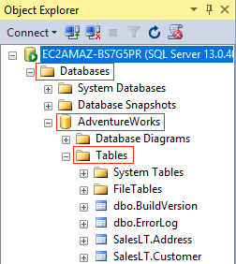

*Image description: The preceding diagram depicts the steps used to navigate to Databases > AdventureWorks > Tables using the Object Explorer.*

A sample *AdventureWorks* database has been loaded onto the local database as part of the lab setup. Examine the tables and the data.

In the next task, you copy this data to the Amazon RDS database.

**Task complete:** You have successfully started the Microsoft SQL Server Management Studio and connect to the SQL Server database that is running locally on the EC2 instance.

**Task 4: Access the RDS instance via Microsoft SQL Server Management Studio**

In this task, you connect the SQL Server Management Studio to the Amazon RDS database and create a new database object.

You first gather the database connection details.

1. At the top of the AWS Management Console, in the search bar, search for and choose

RDS

.

1. In the left navigation pane, choose **Databases**.

Two instances should be listed:

* One that you created earlier (*my-rds*)
* One that was created automatically when you started the lab (*lab*).

The following steps assume you use the **lab** instance, but if your **my-rds** instance has a status of *available*, you can use it instead.

1. Choose the **lab** instance to view the instance properties.

**Note:** You might need to wait here until the Status changes to “backing-up” or “available”.

1. On the **Connectivity & security** tab, copy the **Endpoint** to your text editor. It should look similar to: *lab.xxxxxxxxxx.us-west-2.rds.amazonaws.com*
2. Return to your Remote Desktop session.
3. In **SQL Server Management Studio**, in Object Explorer:

* Choose **Connect**.
* Choose **Database Engine**.

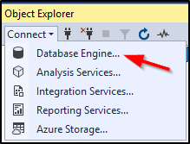

*Image description: The preceding diagram depicts the steps on how to connect to the Database Engine.*

Amazon RDS for SQL Server supports Windows Authentication, and AWS provides several options for using Active Directory in the cloud. For example, you can deploy a Windows domain controller on Amazon EC2; you can use Directory Service Simple AD to proxy requests to your on-premises domain controller; or you can create an Active Directory domain in AWS Directory Services. In this lab you use SQL Server Authentication.

1. In the **Connect to Server** dialog box, configure:

* **Server name:** Paste the endpoint you copied.
* **Authentication:** SQL Server Authentication.
* **Login:**

student

* **Password:** Copy and paste the value of **RDSPassword** provided to the left of these instructions.
* Choose **Connect**.

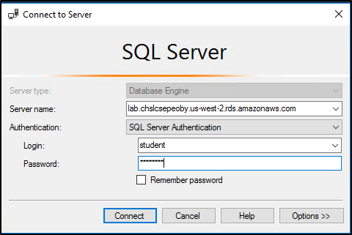

*Image description: The preceding diagram depicts the Connect to Server dialog box with configuration details like Server name, Authentication, Login and Password.*

After a few moment, a new database connection appears in the Object Explorer.

1. In the Object Explorer pane, beneath the RDS instance starting with *lab*.

* Right-click **Databases**, then choose **New Database**.

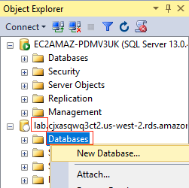

*Image description: The preceding diagram depicts the steps on how to explore a new database connection.*

**Caution:** Make sure you are creating the new database in the remote RDS SQL Server instance (under **lab**) and *not* in the local SQL Server instance (named **EC2AMAZ**).

After a few moments, the **New Database** dialog box appears.

1. In the **New Database** dialog box, for **Database name**, enter

Adventure

.

1. Choose **OK**.

**Task complete:** You have successfully used SQL Server Management Studio to connect to your Amazon RDS instance and created a new database object.

**Task 5: Export AdventureWorks from SQL Server on Amazon EC2 to Amazon RDS**

In this task, you export data from the local database and load it into the Amazon RDS database.

1. In Object Explorer, beneath the local DB instance (the one named **EC2AMAZ** at the top):

* Right-click the **AdventureWorks** database.
* Choose **Tasks** .
* Choose **Export Data…**.

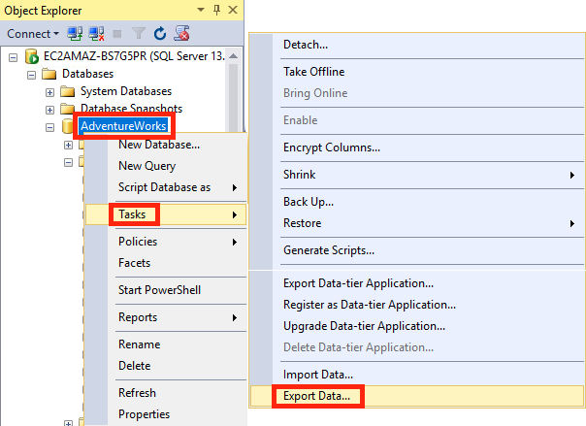

*Image description: The preceding diagram depicts the steps on how to export data from the local database.*

1. On the **Welcome to SQL Server Import and Export Wizard** page, choose **Next >** then configure:

* **Data source:** *SQL Server Native Client 11.0*.
* **Authentication:** Select *Use Windows Authentication*.
* **Database:** *AdventureWorks*.
* Choose **Next >**.

You now configure the Export Wizard to send the data to the *Adventure* database object within your Amazon RDS database instance that you created.

1. On the **Choose a Destination** page, configure:

* **Destination:** *SQL Server Native Client 11.0*.
* **Server name:** Paste the Amazon RDS server Endpoint from the RDS management console (the one you pasted in the previous task).
* **Authentication:** Select *Use SQL Server Authentication*.
* **User name:**

student

* **Password:** Copy and paste the value of **RDSPassword** provided to the left of these instructions.
* **Database:** *Adventure*.
* Choose **Next >**.

1. On the **Specify Table Copy or Query** page:

* Verify that **Copy data from one or more tables or views** is selected.
* Choose **Next >**.

1. On the **Select Source Tables and Views** page:

* Select the checkbox at the very top of the grid. This selects all the checkboxes below it.
* Choose **Next >**.

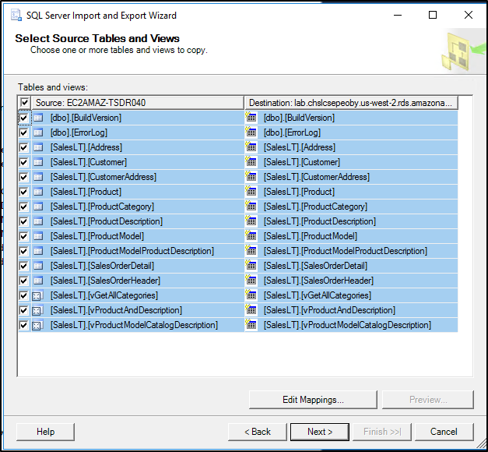

*Image description: The preceding diagram depicts the SQL Server Import and Export Wizard.*

1. On the **Save and Run Package** page:

* Verify that **Run immediately** checkbox is selected.
* Choose **Finish** twice.

The copy operation starts and, within a few moment, it moves all the tables and data to the database in your Amazon RDS instance. Wait until a successful operation message is displayed.

1. Choose **Close**.

Your data is now in the Amazon RDS database!

1. To verify the data transfer, in **Object Explorer**

* Expand the **Databases** object under the *lab* instance.
* Right-click **Adventure**.
* Choose **New Query**.

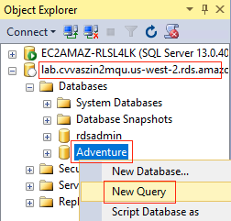

*Image description: The preceding diagram depicts the steps on how to run a new query on the Adventure table from the lab database.*

1. **Command:** In the query window, type or paste the following query to confirm that data has been copied to the destination database:

SELECT * FROM SalesLT.Address

1. Choose  **Execute**

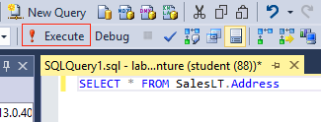

*Image description: The preceding diagram depicts the steps on how to execute a query on the Adventure table from the lab database.*

You should see the list of records displayed in the Results tab at the bottom of the window.

**Task complete:** You have successfully loaded data and executed queries against the Amazon RDS SQL Server instance.

**Conclusion**

You have successfully done the following:

* Created an Amazon Relational Database Service (RDS) SQL Server instance.
* Connected to the RDS instance using Microsoft SQL Server Management Studio.
* Exported data from a local database to an Amazon RDS SQL Server database.

**End lab**

Follow these steps to close the console and end your lab.

1. Return to the **AWS Management Console**.
2. At the upper-right corner of the page, choose **AWSLabsUser**, and then choose **Sign out**.
3. Choose **End lab** and then confirm that you want to end your lab.

**Additional resources**

* [Amazon RDS for SQL Server](https://aws.amazon.com/rds/sqlserver/)

**Appendix**

CONNECT TO YOUR WINDOWS INSTANCE USING RDP

* To the left of the instructions you are currently reading, choose **Download PEM**.
* Save the file to the directory of your choice.
* Open the [Amazon EC2 console](https://console.aws.amazon.com/ec2/).
* In the navigation pane, select **Instances**. Select the **Windows Instance** Instance and then choose **Connect**.
* On the **Connect to instance** page, choose the **RDP client** tab, and then choose **Get password**.
* Choose **Browse** and navigate to the private key (**.pem**) file you created earlier. Select the file and choose **Open** to copy the entire contents of the file to this window.
* Choose **Decrypt Password**. The console displays the default administrator password for the instance under **Password**, replacing the **Get password** link shown previously. Save the password in a safe place. This password is required to connect to the instance.

FOR YOUR RDP CLIENT, USE THE FOLLOWING DETAILS TO CONNECT

* **Windows Instance IP:** Copy and paste the Public IP from the EC2 console.
* **Username:** Enter

**Administrator**

.

* **Password:** Copy and paste the **password** that you saved previously.

[Return to the instructions](https://labs.skillbuilder.aws/sa/lab/arn%3Aaws%3Alearningcontent%3Aus-east-1%3A470679935125%3Ablueprintversion%2Fspl-145%3A2.0.26-0ee7456e/en-US#bastion)

For more information about AWS Training and Certification, see [*https://aws.amazon.com/training/*](https://aws.amazon.com/training/).

*Your feedback is welcome and appreciated.*  
If you would like to share any feedback, suggestions, or corrections, please provide the details in our [*AWS Training and Certification Contact Form*](https://support.aws.amazon.com/#/contacts/aws-training).